  - Meeting minute Agenda and minutes Template:

Student ID: | CTI20221062
Student Name: | Leonardo Matias Ciarcia
Meeting for scenario
Meeting Agenda and Minutes template: ICTNPL413, ICTNWK561, ICTTEN622, and ICTNWK612
Date/Time: | 30/09/2025
Location: | CTI, Level 8, Room number 04, 333 Adelaide St, Brisbane, QLD 4000
Chairperson: | Dijo
Meeting Attendees:  Full names and roles | - Insert the group photo taken during the meeting and the physically signed attendance sheet here  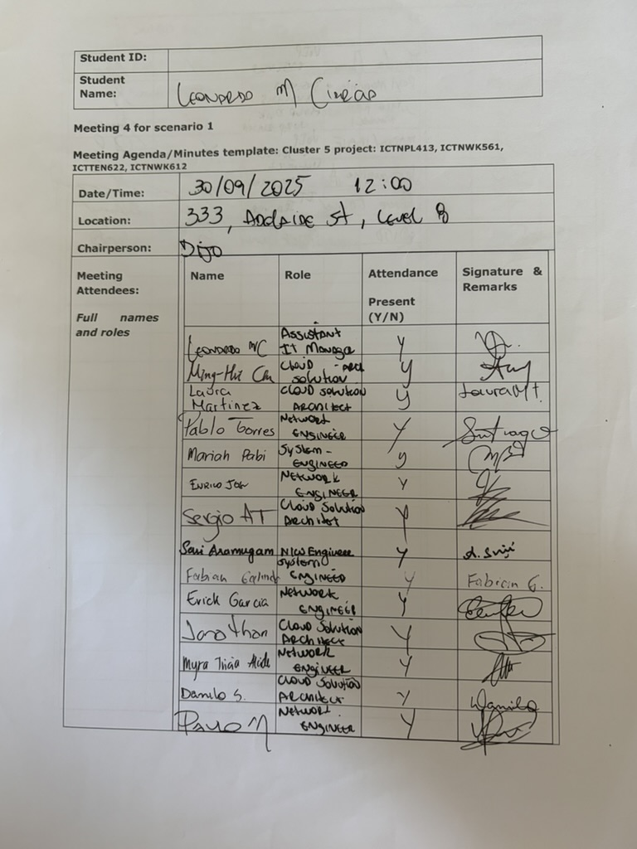  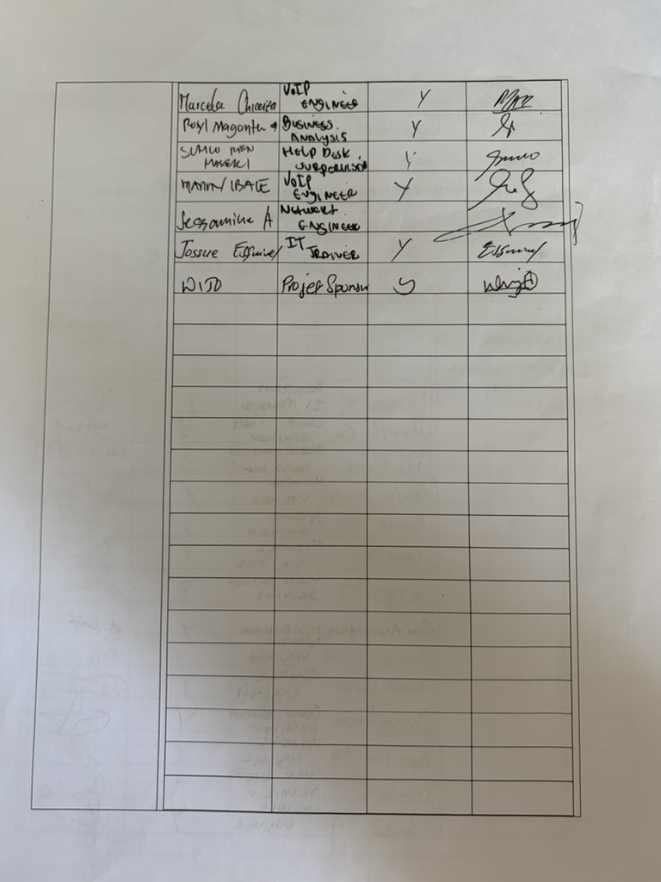  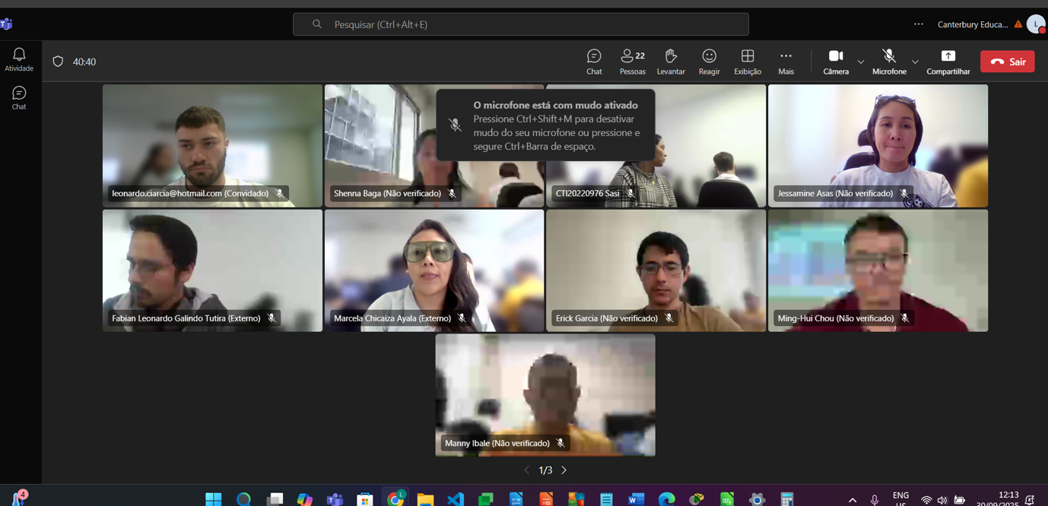  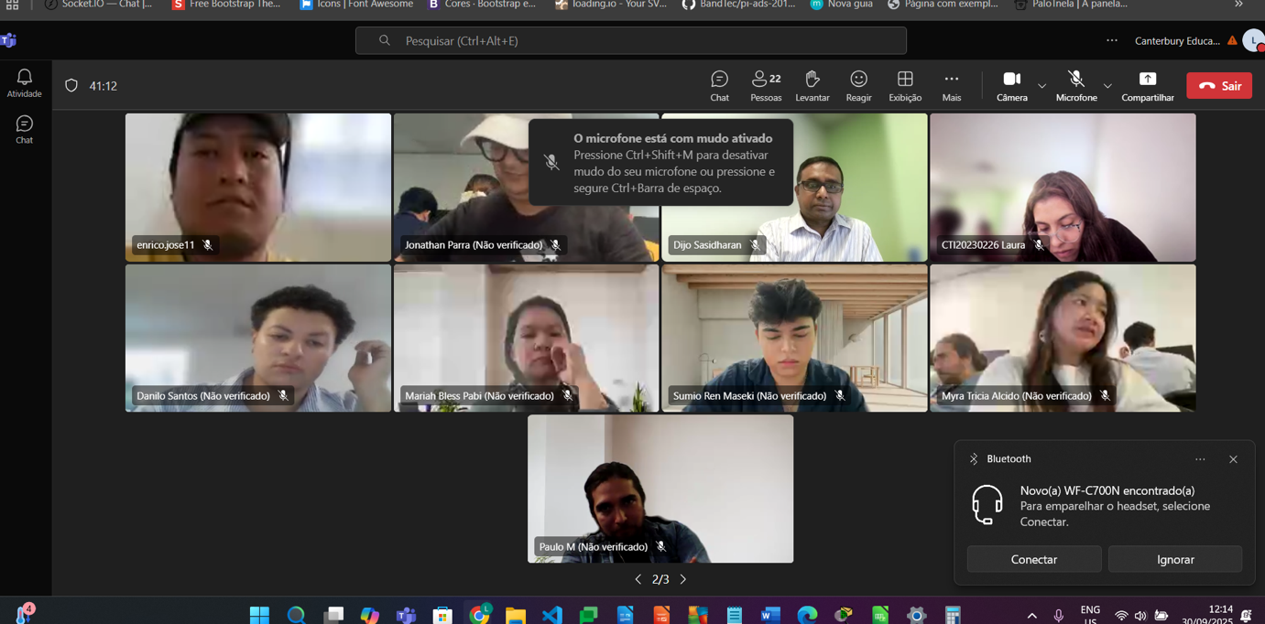  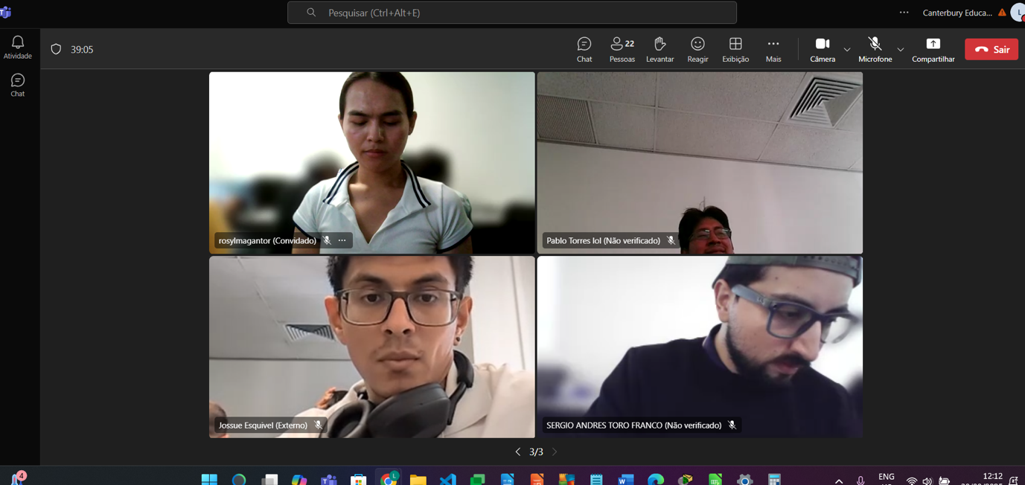
Agenda Item/Topic | Discussion/Activities/Outcomes |  | Action Officer | Target/  Due Date
Welcome | • welcomed the participants and explained the purpose of the network monitoring and troubleshooting meeting.  • The participants were advised that the meeting would cover monitoring plans, troubleshooting strategies, IOS maintenance, testing sequences and the final Network 3 architecture.  • The objective was to ensure that the completed network could be monitored, tested and maintained to achieve acceptable performance and reliability. |  | Leonardo Ciarcia – Assistant IT Manager | At the beginning of the meeting
(Agenda item 1)  Topic?  -Plan to monitor and manage IP network performance and reliability | Motion moved by: Leonardo Ciarcia – Assistant IT Manager  Voting and Resolution: The motion was carried. The proposed network monitoring and management plan was approved. |  | Network Administrator and Assistant IT Manager | Before the network enters operational service
  Details of discussion/activities (Points Discussed/ Activities completed) | Actions Suggested
  • Reviewed the Network 3 topology, IP addressing, VLANs, routing, wireless services, server services and Brisbane–Rookwood VPN.  • Identified monitoring requirements for device availability, interface status, bandwidth utilisation, latency, packet loss, errors and service response times.  • Discussed monitoring of DHCP, DNS, wireless access points, wireless controller, server availability and VPN status.  • Established the network configuration and performance baseline to support future troubleshooting.  • Discussed warning and critical thresholds and the process for recording, prioritising and escalating network alerts.  • Confirmed that monitoring records should be retained to identify performance trends and recurring faults. | • Document the network monitoring plan, performance baseline and thresholds.  • Configure the monitoring server to observe critical devices and services.  • Establish a process for alert escalation and incident recording.
(Agenda item 2)  Topic?  -Network monitoring structure and IOS device maintenance strategies | Motion moved by: Leonardo Ciarcia – Assistant IT Manage  Voting and Resolution: The motion was carried. The monitoring structure and IOS maintenance process were approved. |  | Senior Network Administrator and Security Officer | Maintenance plan to be completed before final handover and followed monthly
  Details of discussion/activities (Points Discussed/ Activities completed) | Actions Suggested
  • Reviewed the monitoring structure for routers, core switches, access switches, servers, wireless devices and WAN connections.  • Confirmed that critical core, server and inter-campus services require higher monitoring priority.  • Discussed routine IOS maintenance, including configuration reviews, backups, software version checks, interface checks and routing verification.  • Reviewed the need to monitor router configurations, routing information, access-control lists and VPN settings.  • Discussed isolation of faults at the appropriate OSI model layer.  • Reviewed the monitoring of security events affecting device administration and mission-critical services.  • Considered IPv4 operation and future IPv4/IPv6 interoperability requirements. | • Create a routine IOS device maintenance schedule.  • Back up verified router and switch configurations after approved changes.  • Review monitoring reports and security events at scheduled intervals.
(Agenda item 3)  Topic?  -Implementation of the advanced network test plan | Motion moved by: Leonardo Ciarcia – Assistant IT Manage  Voting and Resolution: The motion was carried. The advanced network test plan and evidence requirements were approved. |  | Network Testing Officer and Assistant IT Manager | Before client acceptance testing
  Details of discussion/activities (Points Discussed/ Activities completed) | Actions Suggested
  • Reviewed the testing sequence for physical connections, switch-to-switch links, access ports and trunk ports.  • Confirmed that Spanning Tree Protocol and loop-prevention behaviour must be checked.  • Reviewed testing of VLAN assignment, VLAN isolation, switch virtual interfaces and inter-VLAN routing.  • Discussed tests for DHCP address allocation, subnet masks, default gateways, DNS resolution and server accessibility.  • Reviewed wireless tests covering SSID visibility, access point association, security settings and automatic IP allocation.  • Confirmed testing of internet connectivity, NAT and the site-to-site IPsec VPN.  • Identified suitable commands and tools, including ping, tracert, ipconfig, show interfaces, show VLAN, show spanning-tree and show IP route.  • Confirmed representative connectivity tests to internal gateways, 10.10.40.10 and the external test address 209.165.200.10 where applicable. | • Complete and record every test in the approved testing sequence.  • Capture screenshots of successful configurations and test results.  • Correct failed tests and repeat them before client acceptance.
(Agenda item 4)  Topic?  - Network architecture troubleshooting, fault isolation and corrective action | Motion moved by: Leonardo Ciarcia – Assistant IT Manage  Voting and Resolution: The motion was carried. The fault-isolation, corrective-action and rollback procedures were approved. |  | Network Administrator, Wireless Engineer and Assistant IT Manager | Before final project handover
  Details of discussion/activities (Points Discussed/ Activities completed) | Actions Suggested
  • Reviewed the hierarchical architecture and identified logical points where network segments could be isolated without unnecessarily affecting the entire campus.  • Discussed troubleshooting from the physical layer through switching, IP addressing, routing, transport and application services.  • Reviewed previously identified problems involving DHCP allocation, a 0.0.0.0 default gateway, wireless SSID visibility, access point grouping and laptop association.  • Discussed checking DHCP pools, VLAN assignments, trunk links, switch virtual interfaces, access point settings and WLC configuration when clients cannot obtain an address.  • Reviewed procedures for investigating failed internal, server, internet and inter-campus connectivity tests.  • Confirmed that configuration changes must be authorised, recorded, tested and reversed if they create additional faults.  • Discussed escalation procedures, restoration priorities and final incident closure requirements. | • Develop a troubleshooting flow for common wired, wireless, DHCP and routing faults.  • Record the cause, corrective action and retest result for each identified problem.  •Maintain approved configuration backups to support safe rollback and recovery.
Summary | Overall Summary: The meeting established the monitoring, maintenance, testing and troubleshooting requirements for the A-Plus Institute Network 3 solution. The agreed approach covers the five-level Brisbane campus, server services, wireless network, VLAN architecture, external connection and Brisbane–Rookwood VPN.  Decision/s:  • Establish a performance baseline and monitoring thresholds.  • Implement routine IOS device maintenance and configuration backups.  • Complete the advanced network test plan.  • Use structured OSI-based troubleshooting and network-segment isolation.  • Record all faults, corrective actions and retest results.  Action/s if any:  • Finalise the monitoring and management plan.  • Complete the IOS maintenance schedule.  • Perform and document all network tests.  • Prepare the troubleshooting flow and incident records.  • Submit successful test evidence before client sign-off. |  | Leonado Matias Ciarcia | 30/09/2025
Next Meeting time/date | 18/05/2026 |  | Leonado Matias Ciarcia | 30/09/2025
Meeting closed at: | 1PM |  | Leonado Matias Ciarcia | 30/09/2025
Minutes are a true and accurate record of the meeting | Approved/confirmed by: (who?)  Dijo Sasidharan |  | Dijo | 30/09/2025
Signature of attendee 1: Dijo Sasidharan |  | Signature of attendee 3: Leonado Matias Ciarcia

